Step-01
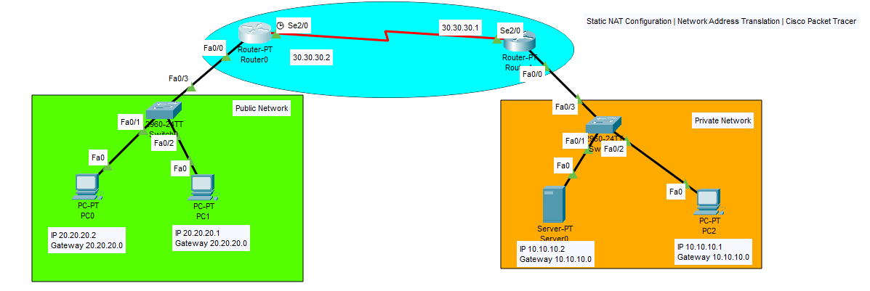
Step-02 Configure NAT on router-01
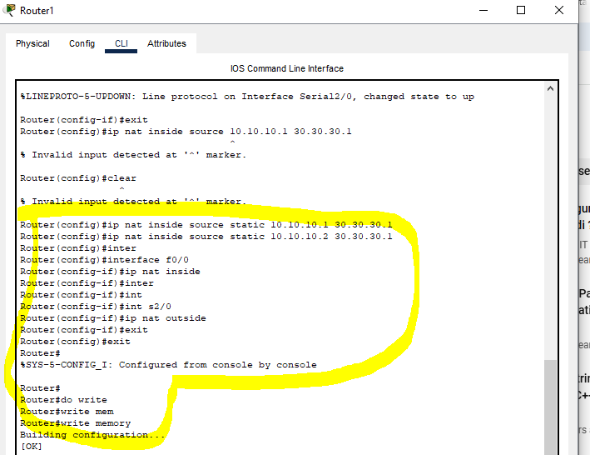

Step-03 Configure Static Routing on router-01
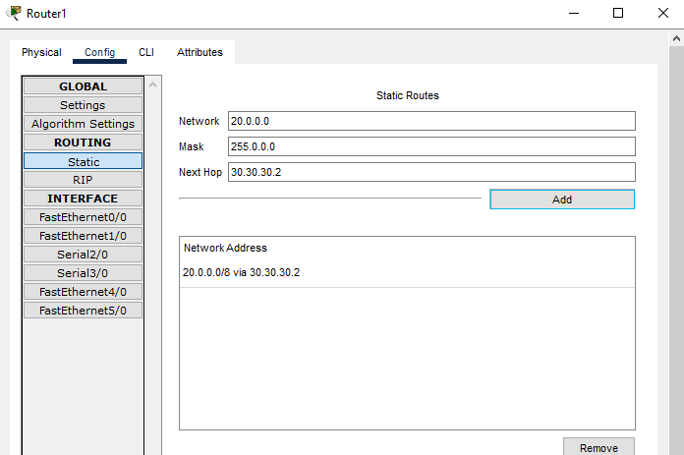
Step-04 Send Packet from Public to private always fail (Public cannot access private address)
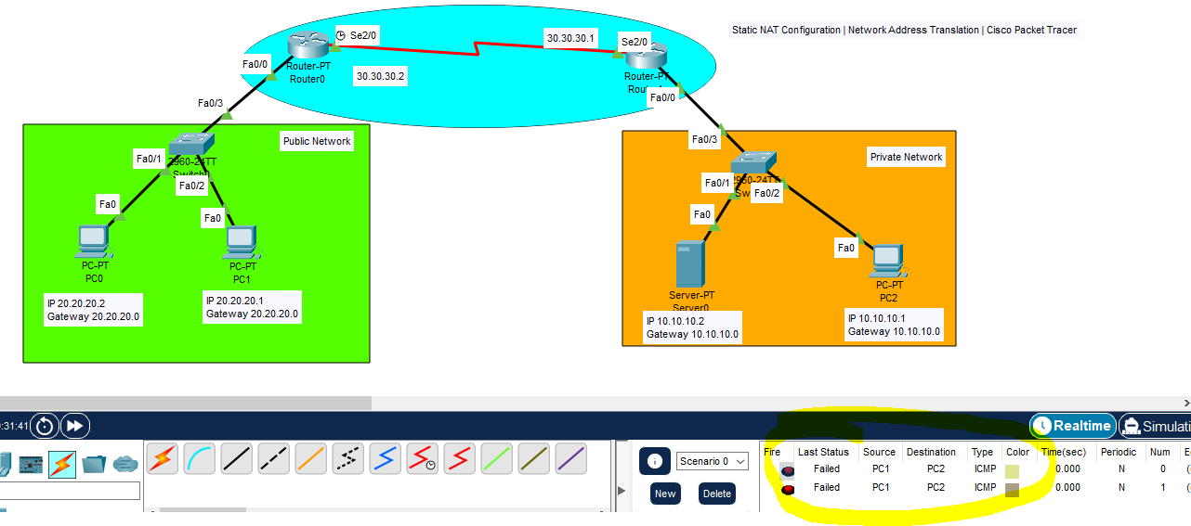

Step-05 Now Ping PC-02 to PC-01
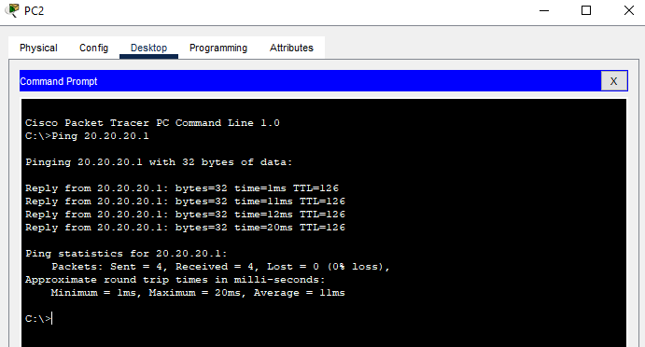

Step-06 Now access Private Network IP 10.10.10.1
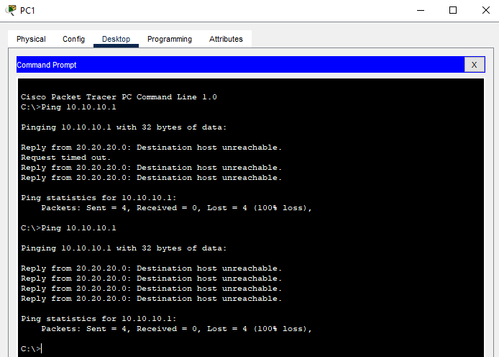
Step-07 Now access public IP 30.30.30.1
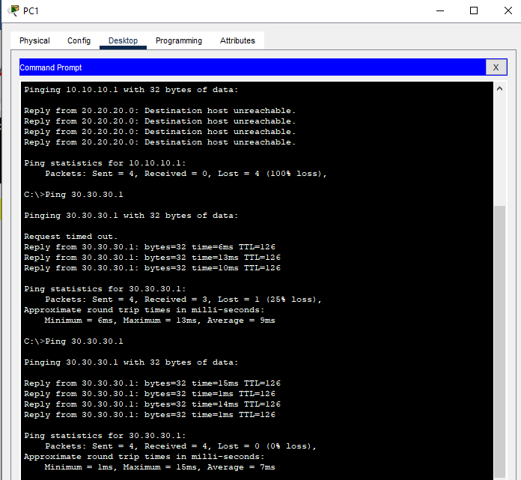

Step-08 Now Open Web browser from PC-1 and open Private Network IP 10.10.10.2 (Not Open)
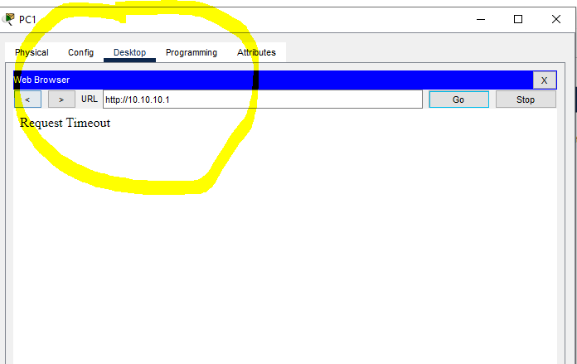

Step-09 Now Open Web browser from PC-1 and open Public IP 30.30.30.1 (Open)
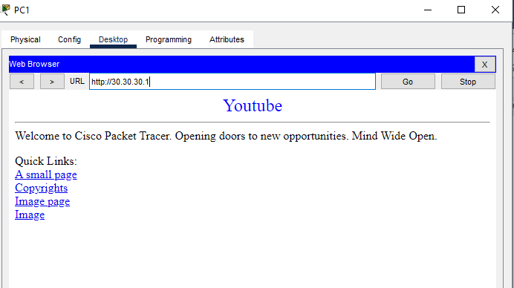

Step-10 Ping PC 2 to PC 1

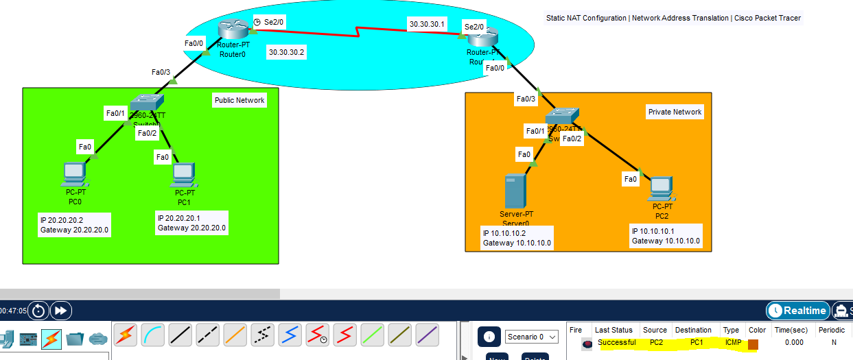

Step-11 Open NAT Table and review
